Design | Make | Evaluate | Apply
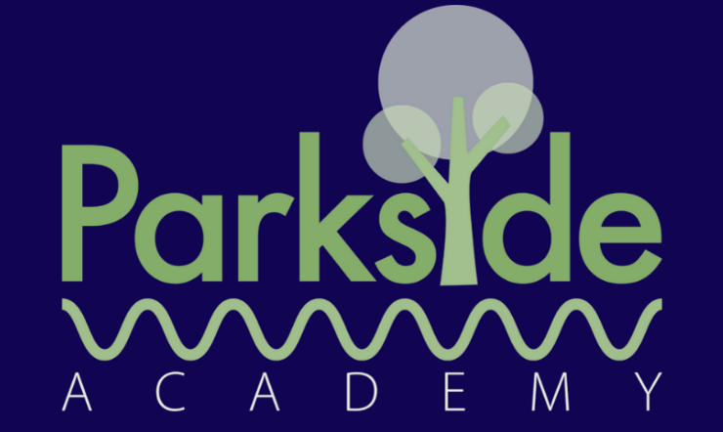


Design and Technology Overview

 | Cooking and Nutrition  Healthy Choices | Structures & Mechanisms  Sliding Scenes Card and Construction |  | Textiles  Minibeast Weaving
EYFS | Learn how to manage own basic hygiene and personal needs including oral health and healthy food choices. | Create collaboratively, sharing ideas, resources and skills.  Return and build on their previous learning, refining ideas and developing their ability to represent them. |  | Safely use and explore a variety of materials, tools and techniques experimenting with design, texture and function. Share their creations, explaining the process they have used.
 | Structures  Constructing Windmills | Cooking and Nutrition  Fruit and Vegetables |  | Mechanisms  Wheels and Axles
Year 1 | Inspired by the song, ‘Mouse in a windmill’, children design and construct a windmill for a client (mouse) to live in. Explore various types of windmill, how they work and their key features.  - To include individual preferences and requirements in my design  - To make a stable structure  - To assemble the components of my structure  To evaluate my project and adapt my design | Children will learn to distinguish between fruit and vegetables and where they grow. They will learn food preparation skills and design a fruit and vegetable smoothie and accompanying packaging.  - To identify if a food is a fruit or vegetable  - To identify where plants grow and which part to eat  - To taste and compare fruits and vegetables  - To make a fruit and vegetable smoothie |  | Pupils learn about the key parts of a wheeled vehicle, to develop an understanding of how wheels, axles and axle holders work. Design and make a moving vehicle.  - To understand how wheels move  - To identify what stops wheels from turning  - To design a moving vehicle  - To build a moving vehicle
Year 2 | Mechanisms  Moving monsters | Textiles  Pouches |  | Cooking and Nutrition  A balanced diet
Year 2 | Children explore levers, linkages and pivots through existing products and experimentation, use this research to construct and assemble a moving monster.  - To look at objects and understand how they move (pivots, levers and linkages)  - To look at objects and understand how they move (making linkages)  - To explore different design options  To make a moving monster | Children learn how to sew a running stitch ready to design, make and decorate a pouch using a template.  - To sew a running stitch  - To sew a running stich (using a template)  - To join fabrics using a running stich  - To decorate a pouch using fabric glue or stitching |  | Children learn about the food groups (carbohydrates, proteins, fruits and vegetables, dairy, oils and spreads) to understand a balanced diet to develop a healthy wrap to meet a design brief.  - To know what makes a balanced diet.  - To taste test food combinations  - To design a healthy wrap  - To make a healthy wrap
Year 3 | Mechanical System  Pneumatic Toys | Cooking and Nutrition  Eating Seasonally |  | Textiles  Cushions
Year 3 | Pupils design and create a toy with a pneumatic system, learning how trapped air can be used to create a product with moving parts while also building on their design knowledge. They will then be introduced to thumbnail sketches and exploded diagrams  - To understand how pneumatic systems work  - To design a toy that uses a pneumatic system  - To create a pneumatic system  - To test and finalise ideas against design criteria | Children discover when and where fruits and vegetables are grown. Learn about the colour of fruits and vegetables and their health benefits.  - To know that climate affects food growth  - To understand the advantages of eating seasonal foods grown in the UK  - To create a recipe that is healthy and nutritious using seasonal vegetables  - To safely follow a recipe when cooking |  | Children learn how to use cross-stitch and appliqué when designing and making a cushion.  - To know how to use a cross-stitch to join two pieces of fabric together.  - To design and cut the template for a cushion  - To know how to use cross-stitch and appliqué to decorate a cushion face.  - To make a cushion that includes appliqué and cross-stitch.
Year 4 | Structures  Pavilions | Digital World  Monitoring Devices |  | Mechanical Systems  Making a Torch
Year 4 | Pupils explore pavilion structures, learning about what they are used for and investigating how to create strong and stable structures before designing and creating their own pavilions, complete with cladding  - To create a range of different shaped frame structures  - To design a structure  - To build a frame structure  - To add cladding to a frame structure | Children design, program, prototype and brand a Micro: bit mindful moments timer, to a specified amount of minutes.  - To create a design criteria for an electronic timer based on analysis of existing products  - To apply understanding of computer programming to instruct and control a Micro:bit to function as a timer  - To design, make and develop a prototype case for my mindful moment timer  - To design a logo for a mindfulness company using computer-aided design |  | Children explore and evaluate a range of existing torches and design a functional torch for a target audience.  - To learn about electrical items and how they work.  - To analyse and evaluate electrical products  - To design a product to fit a specific set of user needs.  - To make and evaluate a torch.
Year 5 | Electrical Systems  Doodlers | Cooking and Nutrition  What Could Be Healthier? |  | Mechanical Systems  Making a Pop-up Book
Year 5 | Pupils will investigate existing Doodler products as well as circuits and motors. They will problem-solve and determine what constitutes an effective, functional Doodler, as well as write design criteria based on what they have learned. Children will build their design with an electric system that includes a motor.  - To understand how motors are used in electrical products.  - To investigate an existing product to determine the factors that affect the product's form and function.  - To put findings from research into practice to develop an improved product.  - To develop a DIY kit for another individual to assemble their product. | Focussing on nutrition, children research and modify a traditional beef bolognaise recipe to make it healthier and cook their new improved version.  - To understand where food comes from  - To understand the term ‘healthy’  - To adapt a traditional recipe  - To complete a food product |  | After choosing a simple story or nursery rhyme, children create a four-page pop-up storybook design. They will also add accompanying captions, incorporating a range of mechanisms and decorative features, including: structures, levers, sliders, layers and spacers  - To design a pop-up book  - To follow my design brief to make my pop up book  - To use layers and spacers to cover the working of mechanisms  - To create a high-quality product suitable for a target user
Year 6 | Cooking and Nutrition  Come Dine With Me | Digital World  Navigating The World |  | Structures  Playgrounds
Year 6 | Research and prepare a three-course meal. Taste-test and score their food. Research the journey of their main ingredient from ‘farm to fork’.  - To research and design a three-course meal  - To prepare a meal using a recipe  - To understand where their food comes from  - To write up a recipe | Program a navigation tool to produce a multifunctional device for trekkers. Combine 3D objects to form a complete product in CAD 3D modelling software.  - To write a design brief and criteria based on a client request  - To write a program to include multiple functions as part of a navigation device  - To develop a sustainable product concept  - To develop 3D CAD skills to produce a virtual model  - To present a pitch to ‘sell’ the product to a specified client |  | Design and create a model of a new playground featuring a pulley system, five apparatus made from three different structures. Creating a footprint as the base, pupils can practise visualising objects in plan view and also get creative with their use of natural features and cladding for their structures  - To design a playground with a variety of structures  - To build a range of structures and a pulley system  - To improve and add detail to structures  - To create the surrounding landscape
Design
The art of process of deciding how something will look or work.
Make
Create something by combining materials or putting parts together.
Evaluate
Form an opinion of the value of quality of something after careful thought.
Apply
Use something or make something work in a particular situation.

Substantive Knowledge  Substantive knowledge is the carefully sequenced, factual knowledge that we learn through our curriculum. It includes concepts, facts, and information about materials, tools, techniques, and processes used in design and making. For example, substantive knowledge in Design and Technology includes understanding different materials like wood, plastic, and metal, and knowing how to use tools like scissors, glue, and tape. By acquiring substantive knowledge, children develop a foundation of understanding that forms the basis for their design and making skills. | Disciplinary Knowledge  Disciplinary knowledge in Design and Technology refers to the specific ways of thinking and working that are unique to this subject. In DT we learn through researching, designing, making and evaluating products. It involves using design thinking processes and applying design and making skills to solve problems and create products. Disciplinary knowledge includes understanding the iterative design process, where children generate and refine ideas, create prototypes, test them, and make improvements. It also includes understanding the importance of collaboration, creativity, and critical thinking in design and making. By developing disciplinary knowledge, pupils learn how to approach design challenges and become effective designers and makers.
Integration of Substantive and Disciplinary Knowledge
In Design and Technology, substantive and disciplinary knowledge are integrated to develop students' overall understanding and skills. By applying substantive knowledge, children are able to identify, select, and use appropriate materials, tools, and techniques to create products. They also use disciplinary knowledge to think critically, analyse problems, generate creative solutions, and evaluate their designs. Through the integration of substantive and disciplinary knowledge, pupils become confident and competent designers and makers.

