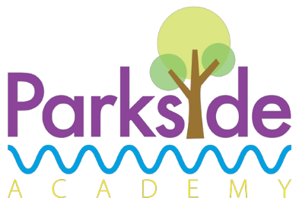
Fish finger wrap
served with chips and mixed salad
or Jacket Potato served with beans/cheese/tuna

or Vegetable fingers
Dessert
Red velvet brownie

Meatballs in gravy
served with mashed potato and sweetcorn
or Jacket Potato served with beans/cheese/tuna
or Vegetarian meatballs
Dessert
Ice cream and peaches

Chunky chicken casserole
served with new potatoes, carrots, peas and crusty bread
or Jacket Potato served with beans/cheese/tuna
or Vegetable casserole
Dessert
Cheese and crackers

Meat Free Monday

Street Food Wednesday

Chip Shop Friday
Around the World Tuesday

Traditional Thursday
Macaroni and cheese
served with broccoli and garlic bread
or Jacket Potato served with beans/cheese/tuna

Dessert
Frozen fruit yoghurt

Daily Alternatives

Deli bar will be available which includes breads, meats, salad, pasta and vegetables.
Packed lunches are also available
these are as an alternative main course option

A smart sweet treat selection will be available daily as an alternative dessert option which may include fruit and yoghurt

Allergen information available upon request

Chicken and chickpea korma
served with pilau rice, naan bread and raita
or Jacket Potato served with beans/cheese/tuna
or chickpea and vegetable curry
Dessert
Fruit jelly and watermelon

Week
2

Parkside Academy

