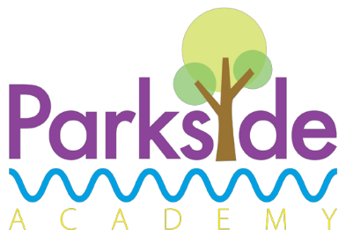
Baked sausages
served with roast and creamed potatoes, farmhouse vegetables and gravy
or Jacket Potato served with beans/cheese/tuna
or Vegetarian sausages
Dessert
Cheese and crackers

Daily Alternatives

Deli bar will be available which includes breads, meats, salad, pasta and vegetables.
Packed lunches are also available
these are as an alternative main course option

A smart sweet treat selection will be available daily as an alternative dessert option which may include fruit and yoghurt

Allergen information available upon request

Tomato and herb pasta bake
served with salad and garlic bread
or Jacket Potato served with beans/cheese/tuna

Dessert
Frozen fruit yoghurt

Tuesday

Meat Free Monday

Street Food Wednesday

Chip Shop Friday
Around the World Tuesday

Traditional Thursday
Chicken breast burger
served in a bun with salad and coleslaw
or Jacket Potato served with beans/cheese/tuna
or Vegetable burger

Dessert
Ice cream and peaches

Seasoned chicken wrap
served with savoury rice
or Jacket Potato served with beans/cheese/tuna
or Seasonal vegetable wrap

Dessert
Fruit jelly and watermelon

Week
3

Parkside Academy

Fish goujons
served with chips and peas
or Jacket Potato served with beans/cheese/tuna
or Vegetable fingers

Dessert
Carrot cake

